Queensland Government (Australia): “This fiscal year is a golden investment opportunity for Vietnamese investors”

In the recent seminar organized by HALI Australia, Mr. Greg McKean - Manager of Business and Skilled Migration Queensland (BSMQ) shared attractive incentives when investing in Queensland.

The Australia Investment Visa: Meeting face-to-face with the Manager of Queensland State Government Seminars, which were held on August 24 in Ho Chi Minh City and August 30 in Hanoi, provided various opportunities to entrepreneurs and investors wishing to migrate to Australia.

The seminars were organized by HALI Australia in partnership with the Queensland Government, Real Asset Management (RAM Group), and iPAN Property.

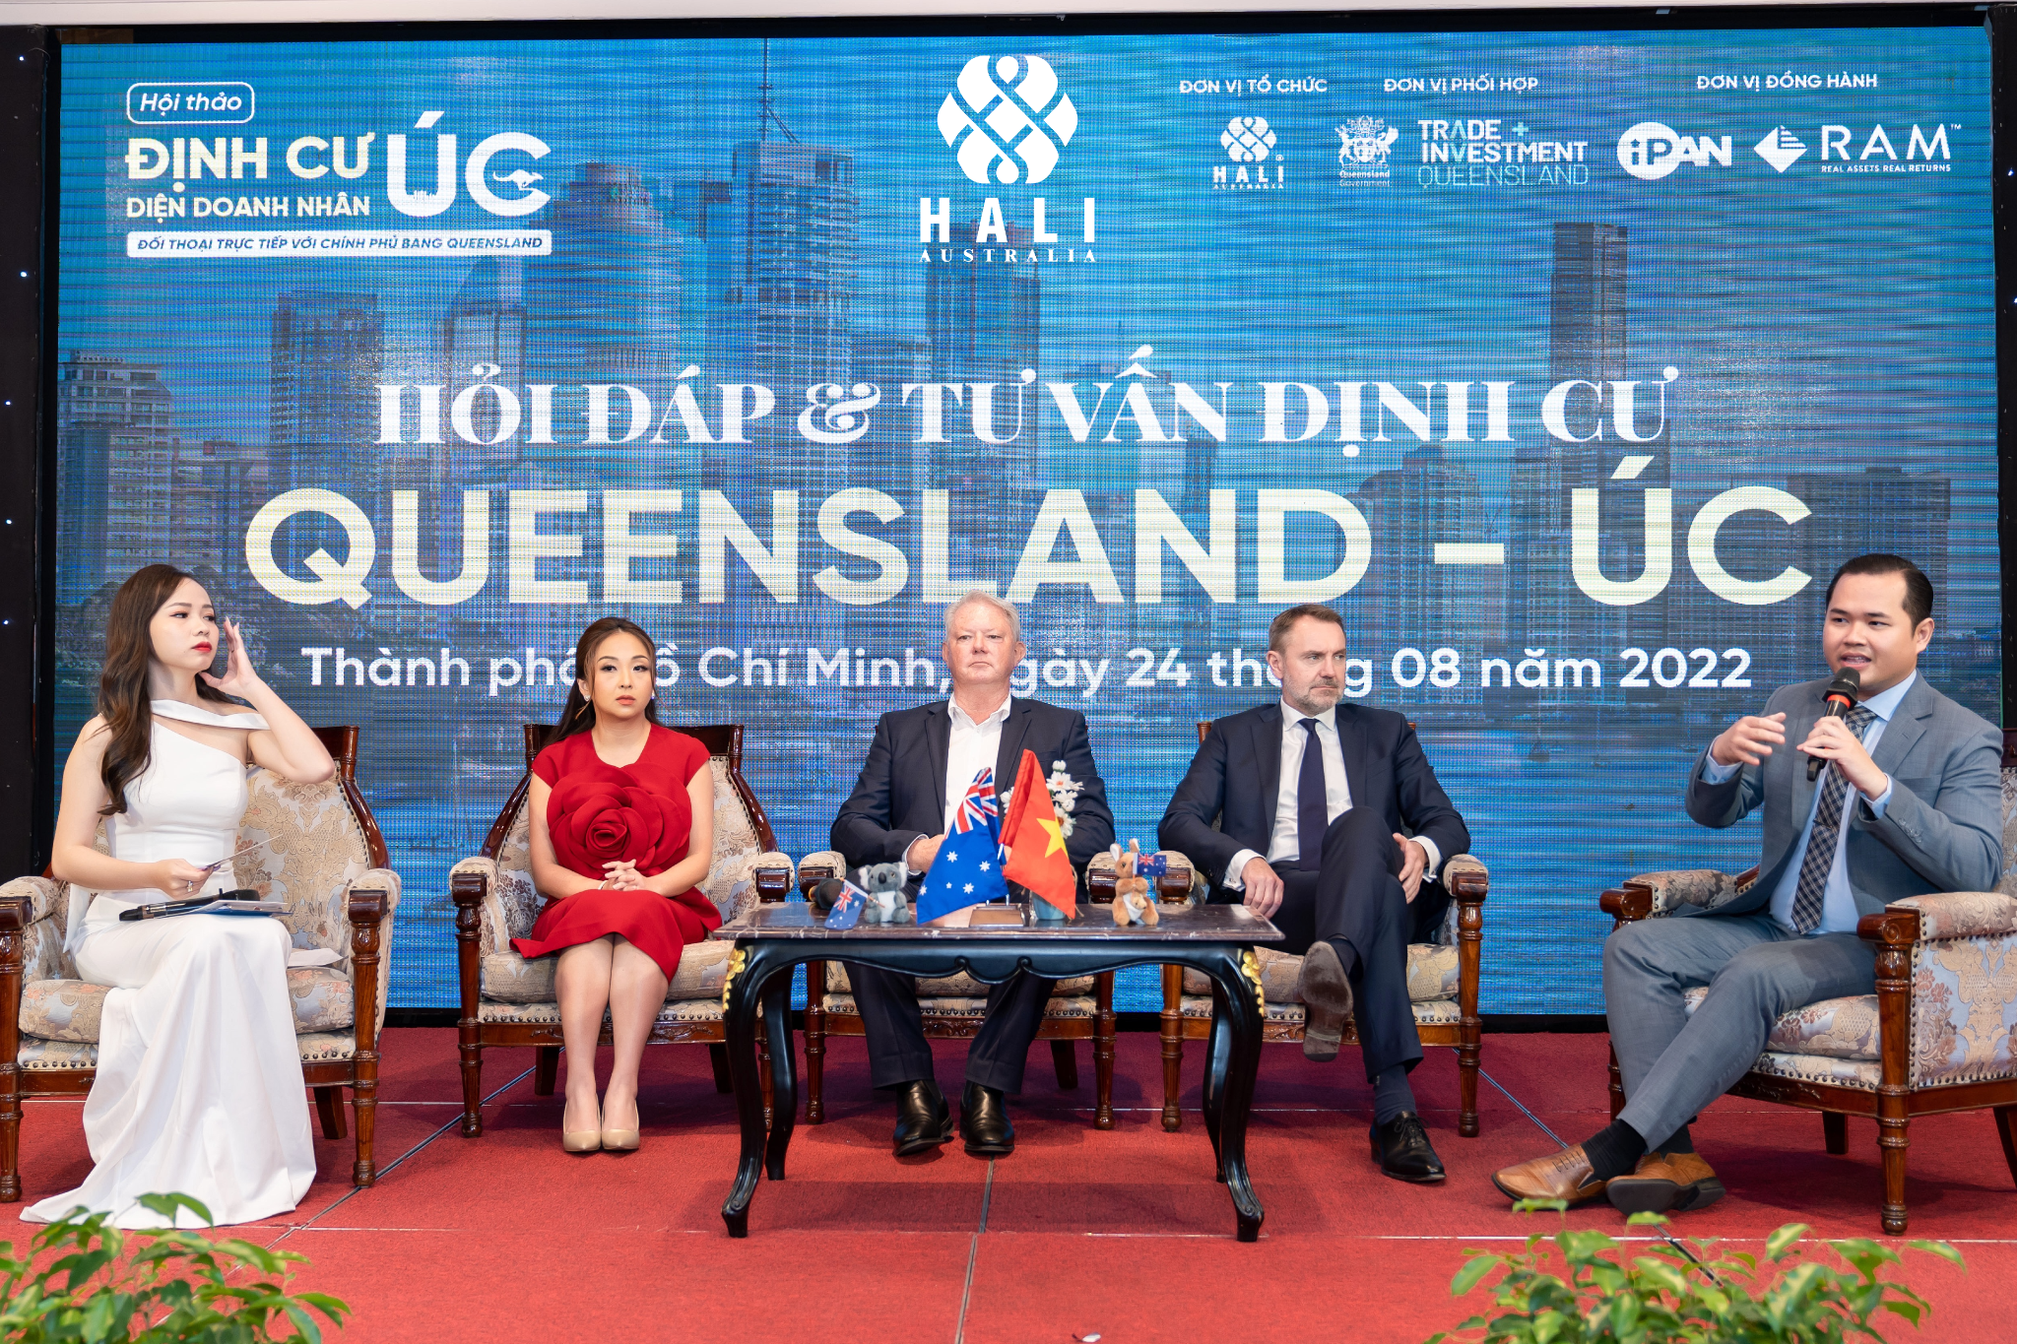

The seminars have the participation of leading experts from Australia: Mr. Greg McKean - Manager of Business and Skilled Migration Queensland (Australia); Mr. Long Phan - Registered Migration Advisor (MARN 1677976); Mrs. Yuvi Kelvin - Director of iPAN Property; and Mr. Scott Kelly - CEO Australia of Real Asset Management (RAM Group); along with entrepreneurs and investors in Ho Chi Minh City and Hanoi who are interested in the investment-settlement program in Queensland in particular and Australia in general.
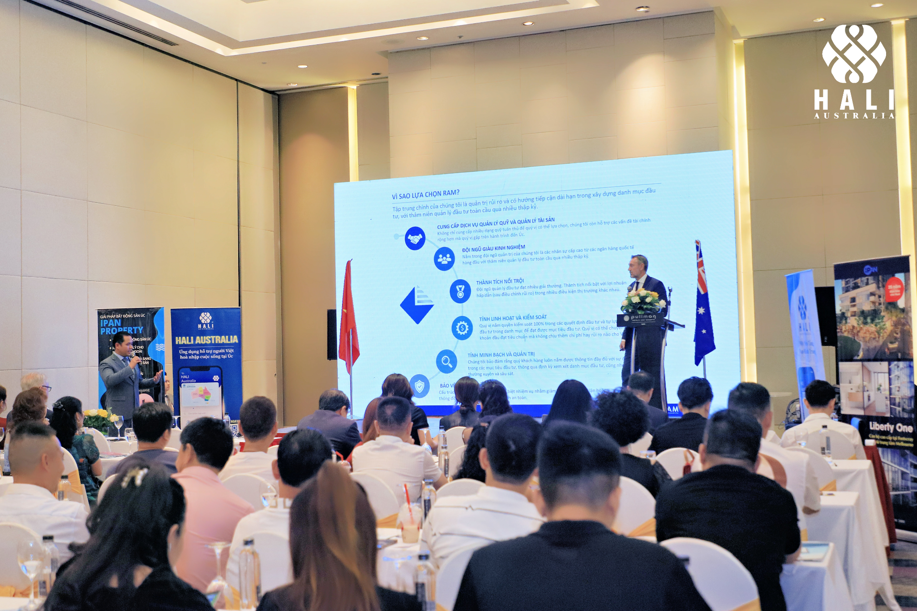

Previously, HALI Australia has successfully organized many Australian Immigration Investment Seminars with the participation of the New South Wales Government and Queensland Government, as well as representatives of Australia's leading corporations. It has built a strong reputation for HALI Australia in the Vietnamese community interested in Australia. The success of these recent seminars in two major cities of Vietnam has confirmed the prestige of HALI Australia as a premier organizer of Australian immigration investment events with the participation of the state government representatives. Therefore, investors and their families can confidently choose HALI Australia as their exclusive partner offering full assistance for all associated services in the process of making investments and settlements in Australia.

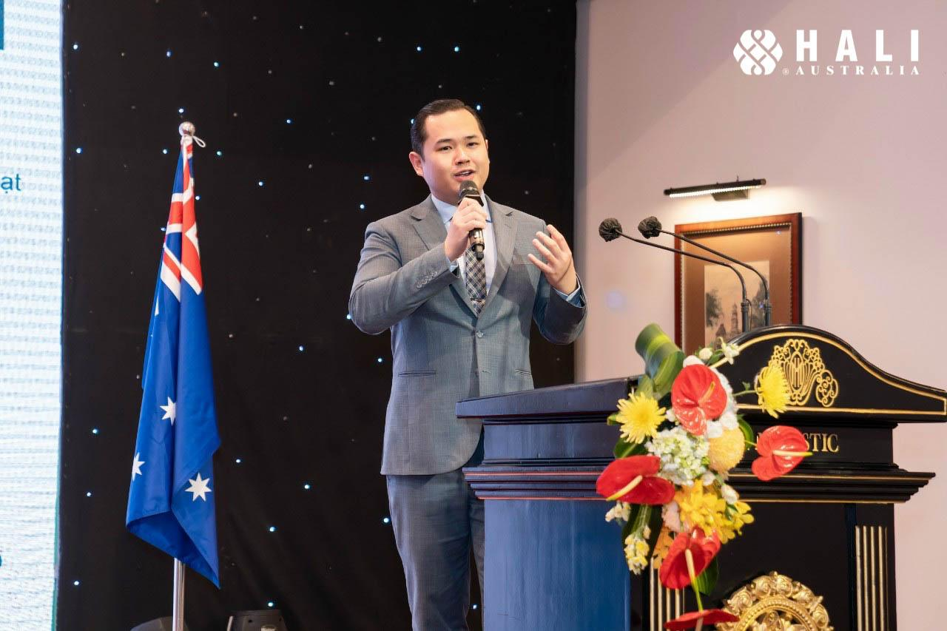
Mr. Long Phan - Registered Migration Advisor (MARN 1677976)

In this seminar, Mr. Greg McKean and Mr. Long Phan - Registered Migration Advisor, respectively presented information on the Australian immigration investment program for the financial year 2022-23. In particular, prominent information related to the requirements of the visa subclasses: 188A Visa - Business Innovation Stream, 188B Visa - Investor Stream, 188C Visa - Significant Investor Stream, 188E Visa - Entrepreneur Stream, and 858 Visa - Global Talent Visa was presented.

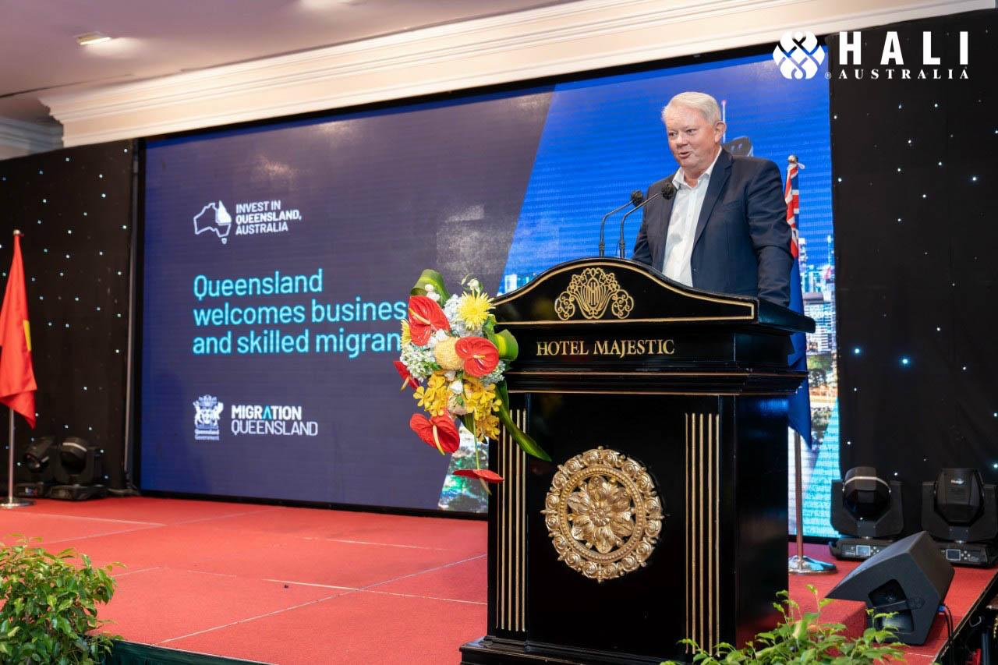
Mr. Greg McKean - Manager of Business and Skilled Migration Queensland (Australia)

At the seminar, Mr. Greg McKean, Manager of Business and Skilled Migration Queensland (Australia) stated that the current surge of migration from major cities such as Sydney and Melbourne has created several opportunities for real estate investment. Notably, companies also benefit from tax incentives for businesses, competitive utility costs, and low office rental prices.

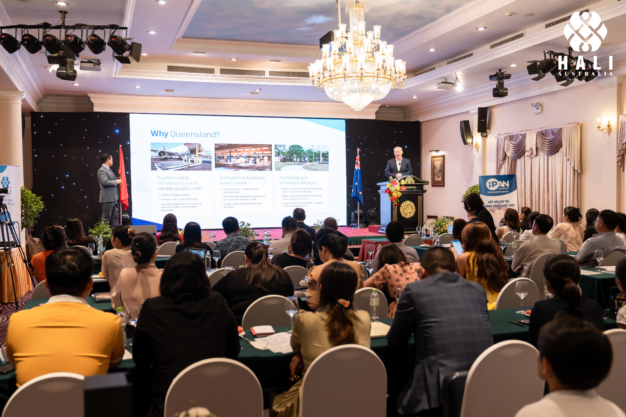

Mr. McKean also stated that Queensland has a mostly bilingual and highly skilled workforce. In addition, Queensland's lifestyle can also help Queensland attract a large number of international workers, helping businesses find qualified employees.

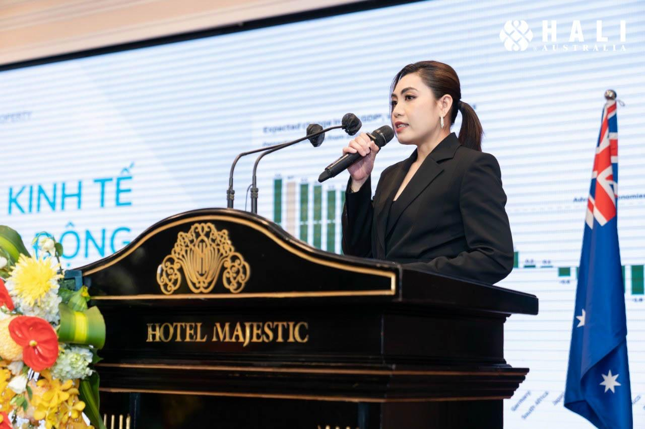
Ms. Trish Le - Sales Director of iPAN Property

Also, Ms. Trish Le - Sales Director of iPAN Property emphasized to the attendees that this is the right time to invest in real estate in Queensland. The Australian real estate market is fast-growing and dynamic. Queensland's house prices are currently lower than in other states. Its growth rate is 26% while the average house price in Australia is only 21%. Furthermore, it is anticipated that this price will keep rising soon.

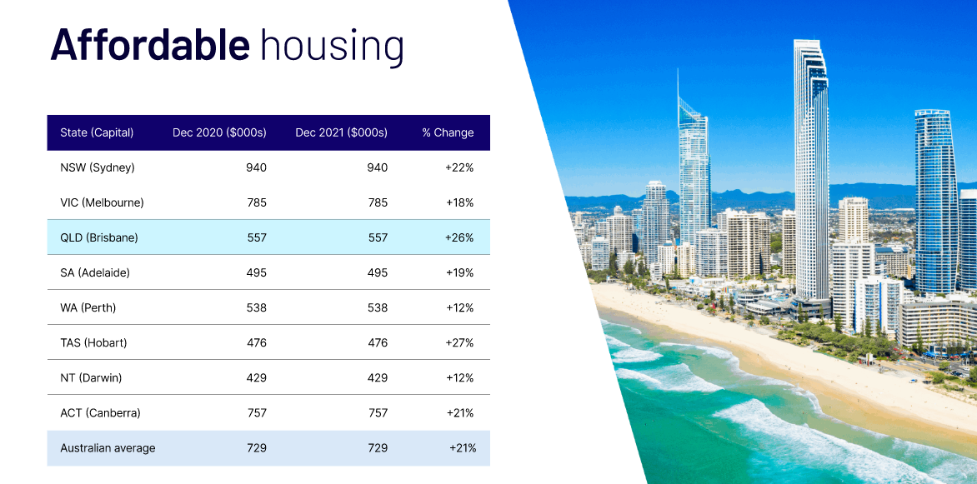

In addition, in 2022 - 2027, major cities in Queensland are actively developing infrastructure and transport systems in preparation for the 2032 Olympic and Paralympic Games in Brisbane. In detail, $1.21 billion is to build a high-speed rail line connecting Brisbane, Logan, Beenleigh, and the Gold Coast; $1.244 billion to build the Brisbane Metro line; $1.1 billion to upgrade Brisbane Airport and $5 billion to build and renovate stadiums.

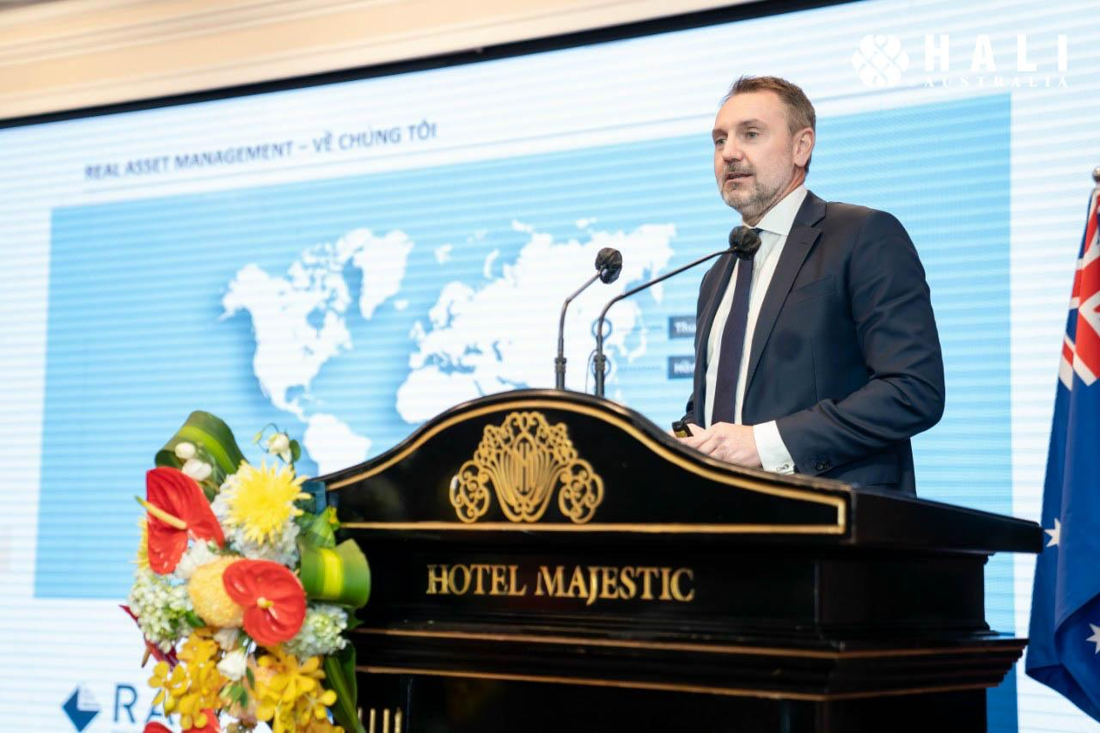
Mr. Scott Kelly - CEO Australia of Real Asset Management Pty Ltd (RAM Group)

Besides the latest information on the Investment Visa stream in FY 2022-23, and potential real estate projects, Mr. Scott Kelly - CEO Australia of Real Asset Management Pty Ltd (RAM Group) also shared with Vietnamese investors useful information about the investment for visa pathway 188B & 188C; and how investment through RAM Group meets the Queensland Business Visa Requirements.

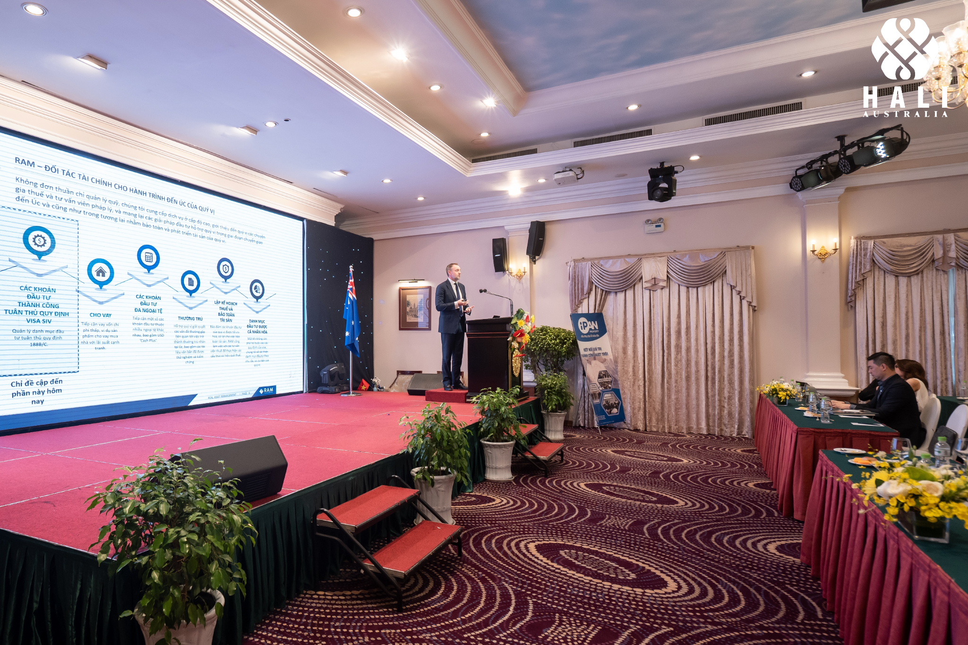

RAM Group is an Australian owned wealth and asset manager specializing in the SIV & IV visa pathway and providing investment solutions for institutions and wealthy families globally. RAM Group manages in excess of $3.5 billion in assets and has offices in 3 major cities in Australia: Sydney - Melbourne - Brisbane. The company owns and manages more than 40 commercial assets across Australia, where 16 of these assets are in Queensland, valued at around $466 million.

With robust economic growth, flexible investment strategies, supportive government policies, and potential real estate projects, this is the ideal time for investors to consider investment and settlement opportunities in Queensland.

Below are photos of the events on August 24th, 2022, in Ho Chi Minh City and August 30th, 2022 in Hanoi.

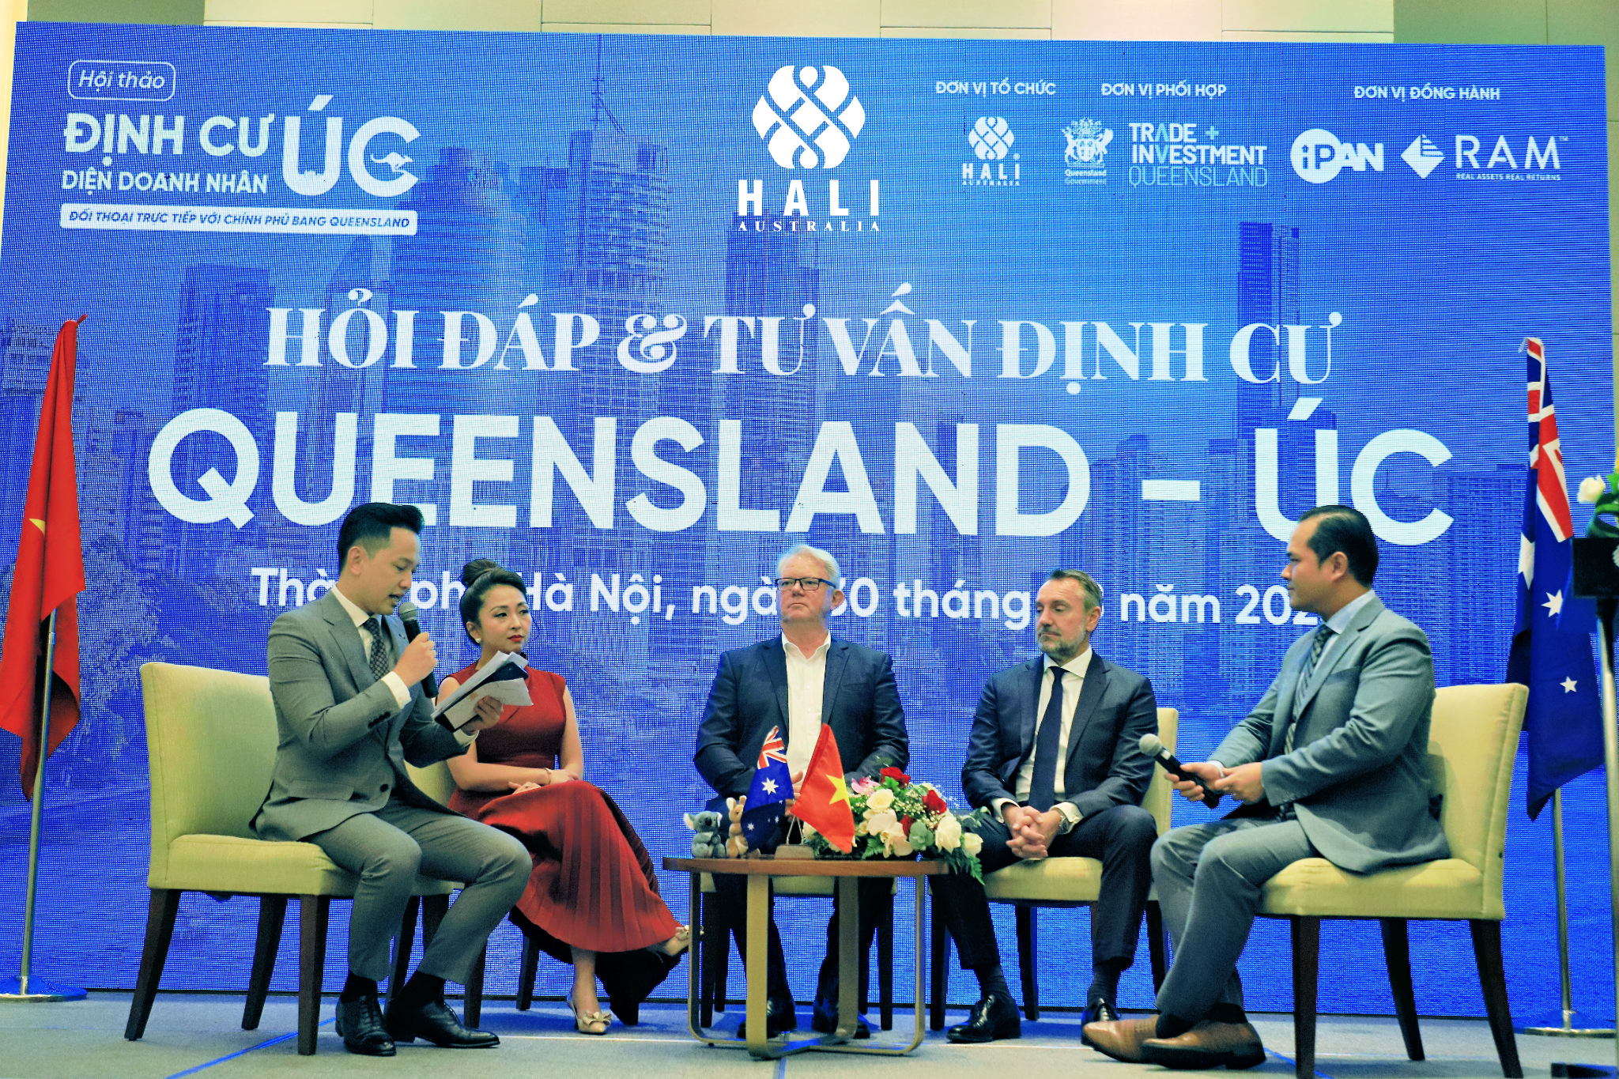

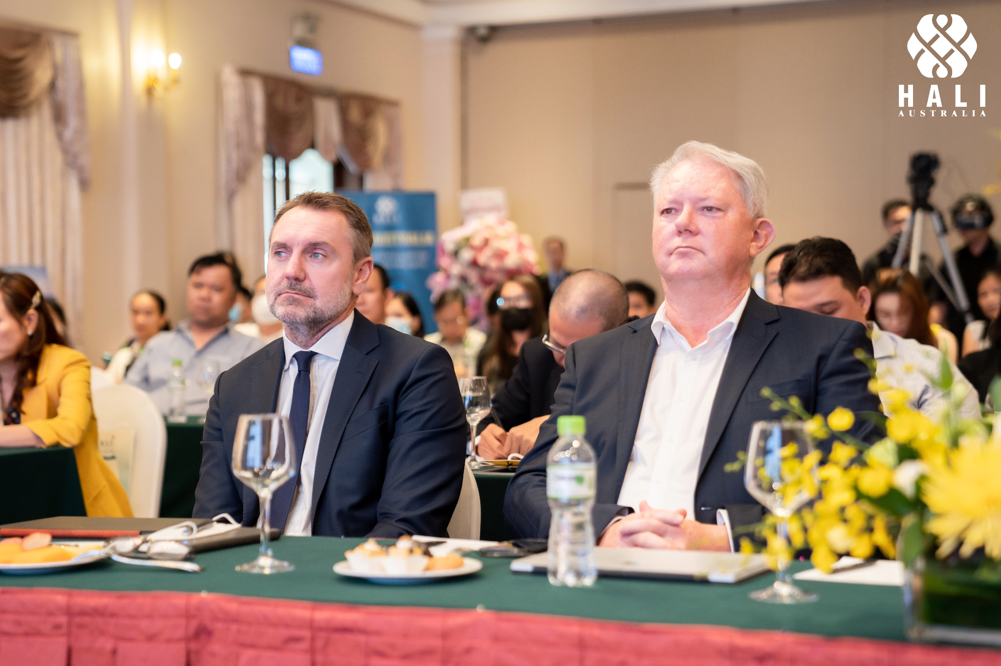

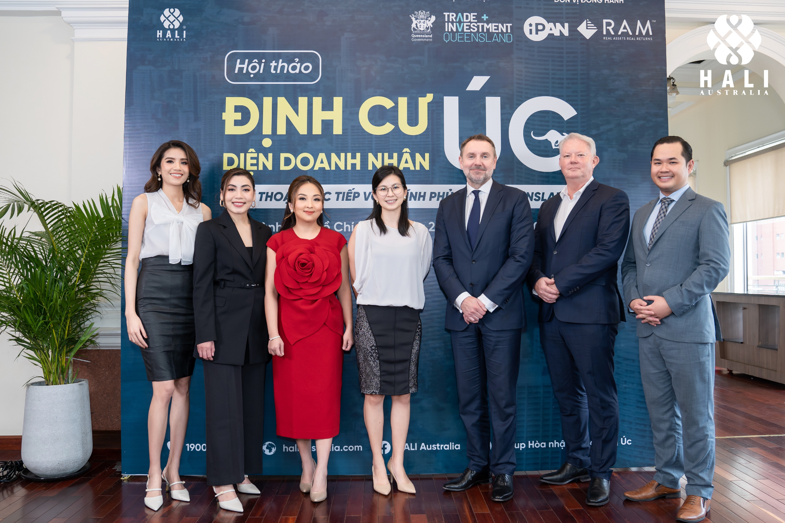

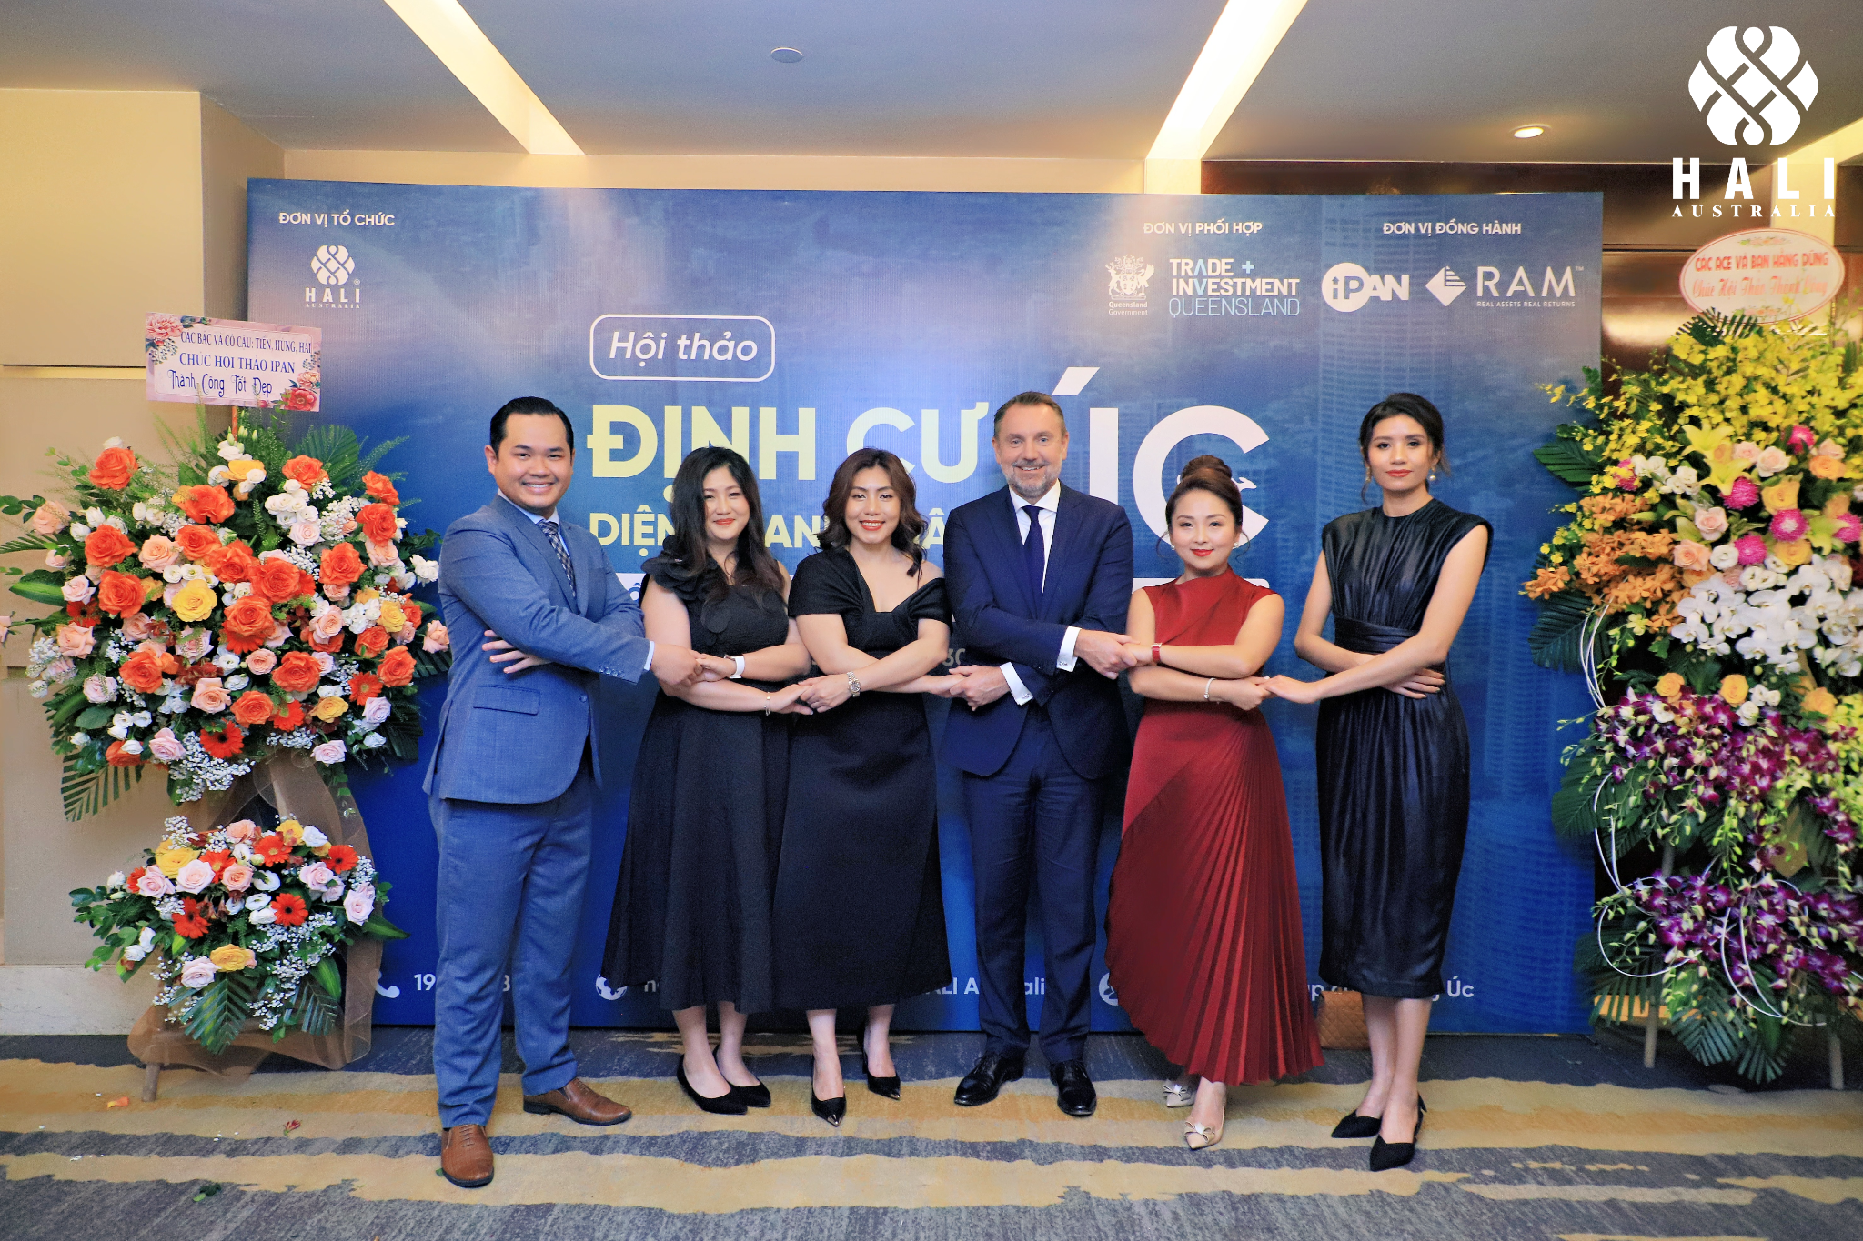

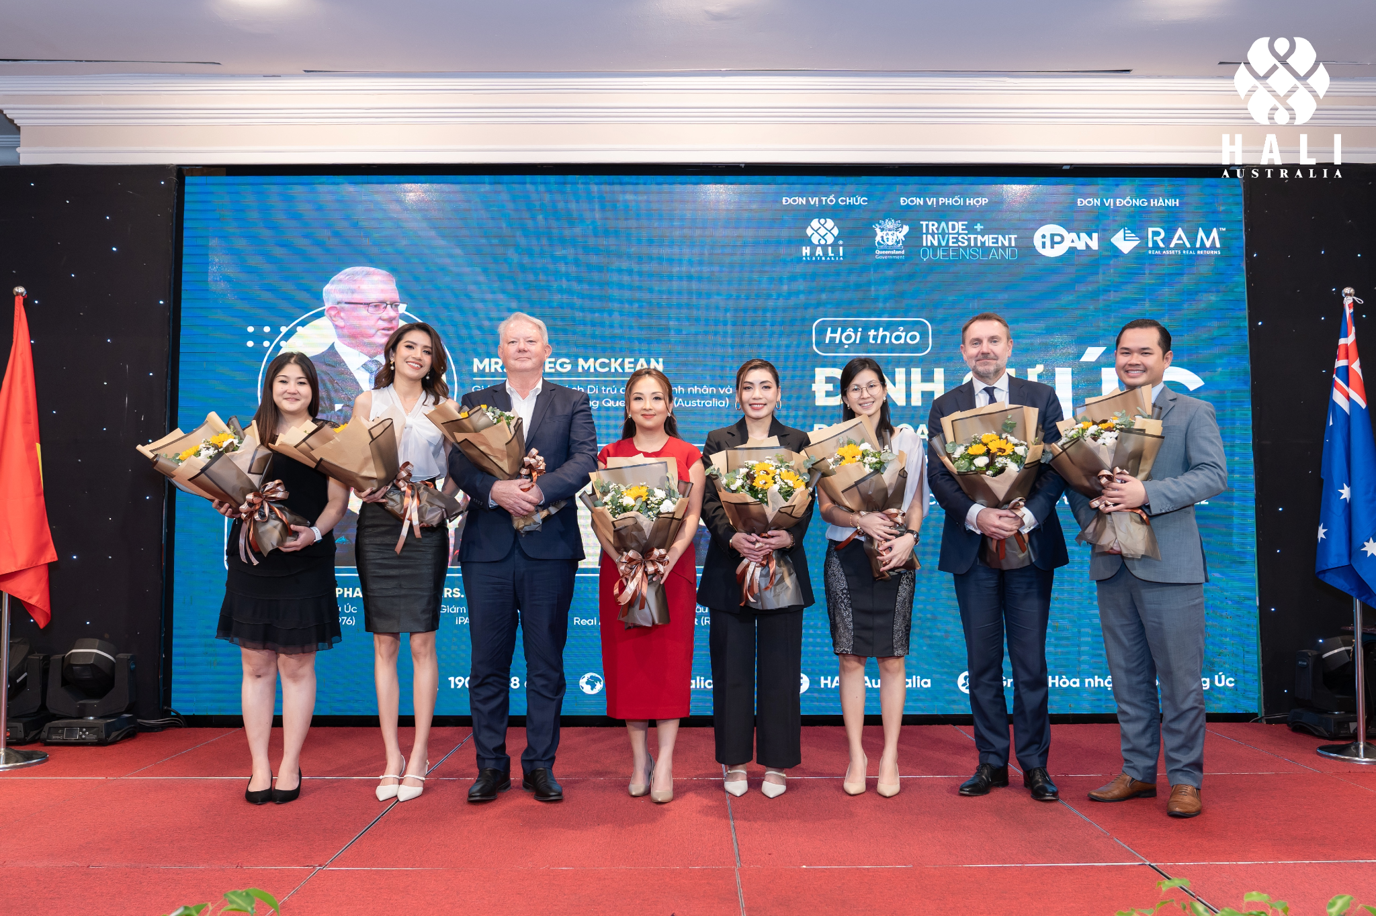

With the motto "One Platform - Endless Solutions", HALI Australia focuses on assisting Vietnamese people in integrating and settling into life in Australia as quickly as possible. In particular, to connect Vietnamese entrepreneurs with reliable partners in Australia, as well as provide investment and settlement opportunities to Vietnamese entrepreneurs and investors, HALI Australia officially organizes the Australian Premium Exploratory Tour 2022.

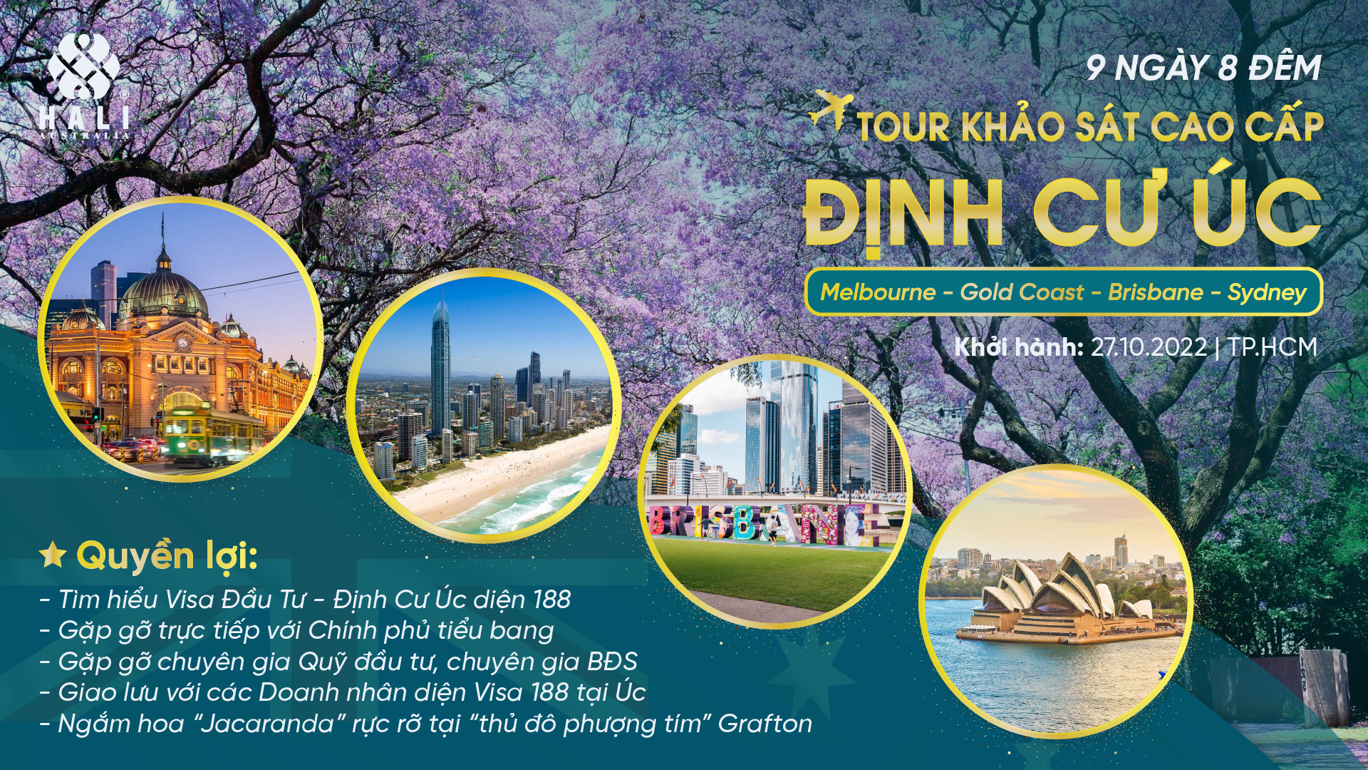

The tour program is designed for clients to experience the Australian culture and lifestyle, and explore the business investment environment and potential real estate projects in Australia. This is a 5-star tour with a duration of 9 days and 8 nights, which travels across Australia's four major cities including Melbourne, Gold Coast, Brisbane, and Sydney. Our tour promises to be an absolutely unforgettable experience!

TOUR INFORMATION
* Duration: 9 days 8 nights
* Departure date: October 27, 2022, from Ho Chi Minh City
* Itinerary: Melbourne – Gold Coast – Brisbane – Sydney
* Click HERE to see the detailed schedule.

HALI Australia - One Platform. Endless Solutions.
 Email: wecare@haliaustralia.com ​
 VN Hotline: 1900 888 680 | AU Hotline: 0290 567 688
 Website: https://haliaustralia.com/
 Group: https://www.facebook.com/groups/hoanhapcuocsonguc

